**DOCUMENT #1**

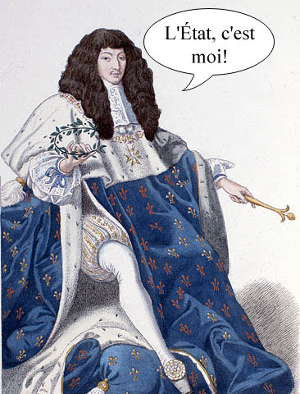

**When Louis was younger, nobles led riots that threatened the young king’s life. After the violence was over, Louis never forgot his fear or his anger at the nobility.**

**When he was 22, he weakened the power of the nobles by excluding them from his councils. He increased the power of the government agents called intendants, who collected taxes and administered justice. To keep power under central control, he made sure that local officials communicated regularly with him.**

**DOCUMENT #2**

**Louis devoted himself to helping France attain economic, political, and cultural brilliance. His minister of finance, Jean Baptiste Colbert tried to make France self-sufficient. He wanted it to be able to manufacture everything it needed instead of relying on imports.**

**Colbert also recognized the importance of colonies, which provided raw materials and a market for manufactured goods. The French government encouraged people to migrate to France’s colony in Canada. There the fur trade added to French trade and wealth.**

**In France, religious conflicts between Catholics and French Protestants (Huguenots) caused much turmoil and fighting. In 1598, Louis’ grandfather declared religious tolerance in the document known as the “Edict of Nantes.”**

**In 1685, Louis canceled the Edict of Nantes which protected the freedom of the Protestants. Thousands of Huguenot artisans and business people fled the country. This robbed France of many skilled workers.**

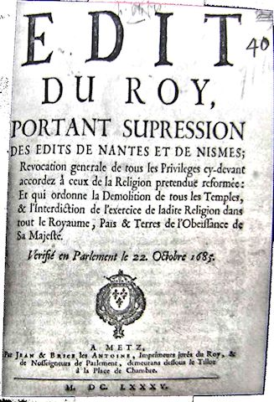

**DOCUMENT #3**

**In his personal finances, Louis spent a fortune to surround himself with luxury. For example, each meal was a feast. An observer claimed that the king once devoured four plates of soup, a whole pheasant, a partridge in garlic sauce, two slices of ham, a salad, a plate of pastries, fruit, and hard-boiled eggs in a single sitting! Nearly 500 cooks, waiters, and other servants worked to satisfy his tastes.**

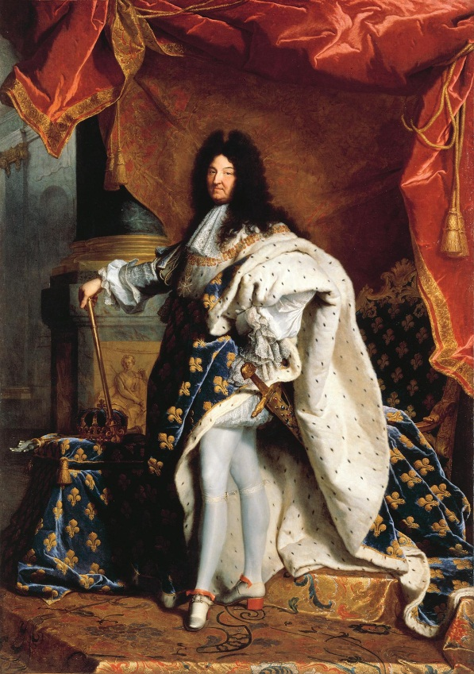

**DOCUMENT 4**

**Louis required hundreds of nobles to live with him at the splendid palace he built at Versailles, about 11 miles southwest of Paris. Having the nobles at the palace increased royal authority by making the nobility totally dependent on Louis. Everything about the Versailles palace was immense. It faced a huge royal courtyard dominated by a statue of Louis XIV. The palace itself stretched for a distance of about 500 yards. Because of its great size, Versailles was a small royal city. Its rich decoration and furnishings clearly showed Louis’s wealth and power to everyone who came to the palace. (2.5 billion $$)**

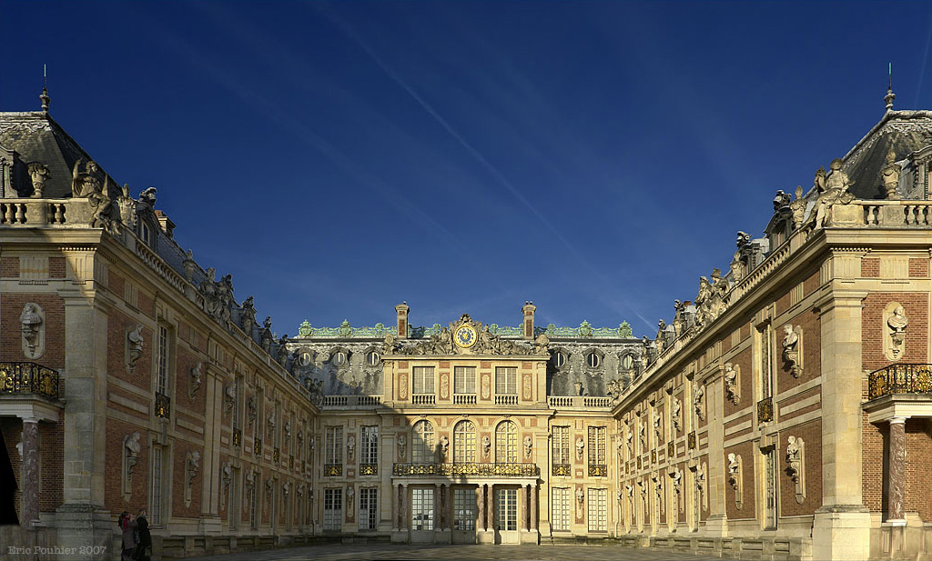

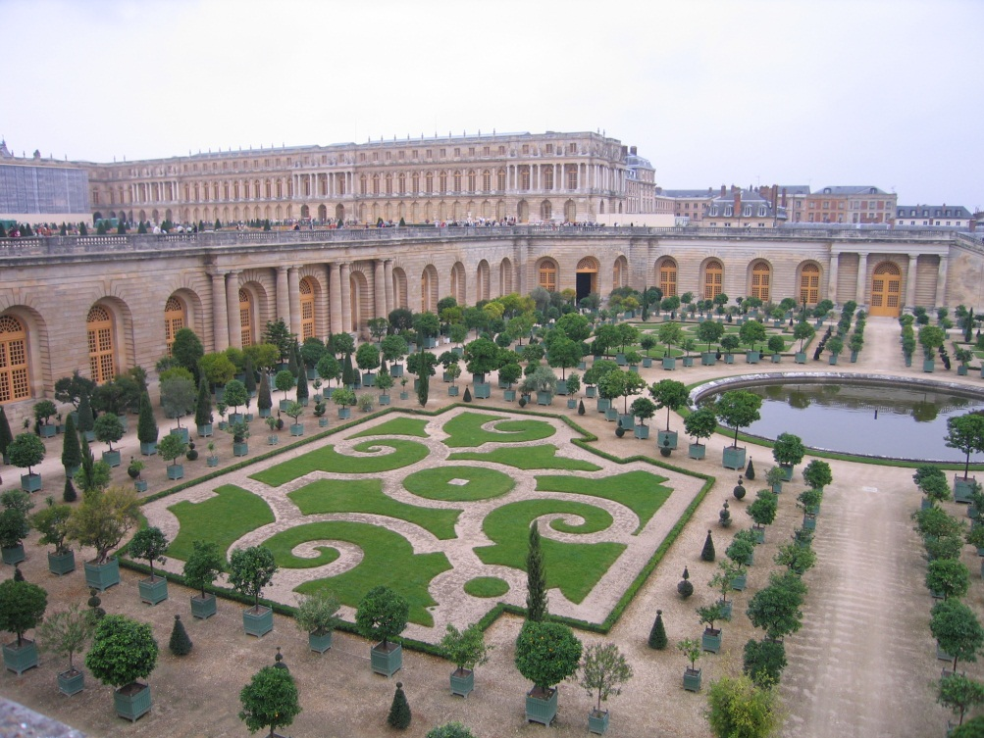 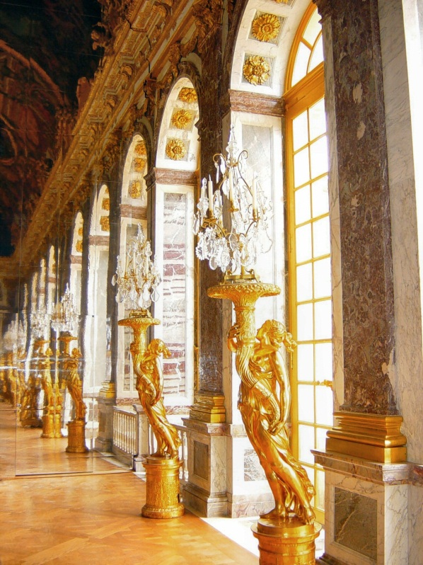

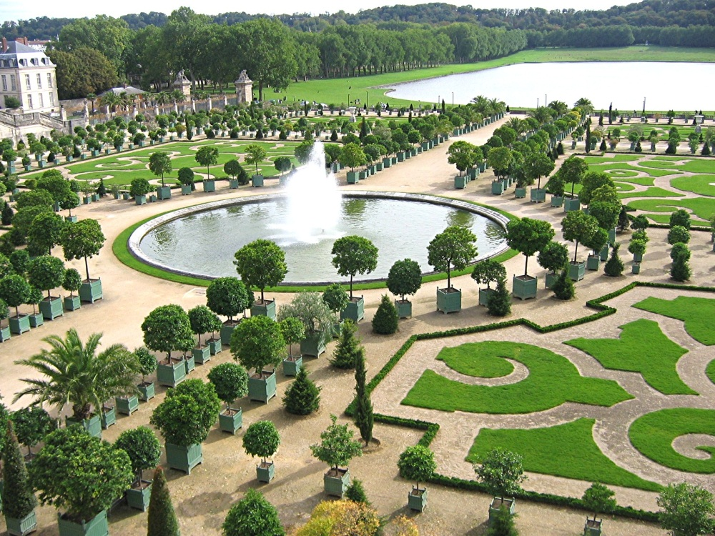

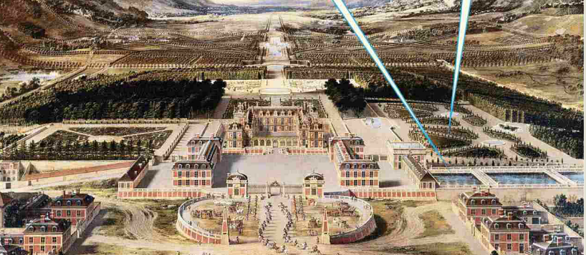

**DOCUMENT #5**

**The Sun King**

**Louis’s nickname**

**Versailles was a center of the arts during Louis’s reign. Louis made opera and ballet more popular. He even danced the title role in the ballet *The Sun King*.**

**Not since Augustus of Rome had there been a European monarch who supported the arts as much as Louis. Under Louis, the chief purpose of art was no longer to glorify God, as it had been in the Middle Ages. Nor was its purpose to glorify human potential, as it had been in the Renaissance. Now the purpose of art was to glorify the king and promote values that supported Louis’s absolute rule.**

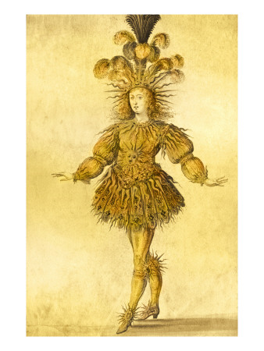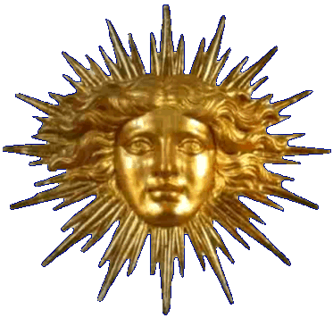

**DOCUMENT #6**

**Under Louis, France was the most powerful country in Europe. The French army was far ahead of other states’ armies in size, training, and weaponry. Louis wanted to expand France’s boundaries by invading several towns. After succeeding in gaining several towns, a European-wide alliance had formed to stop France. By banding together, weaker countries could match France’s strength. Poor harvests coupled with constant warfare and warfare taxes brought great suffering to the French people.**

**In 1700, the childless king of Spain died after promising his throne to Louis’s 16 year old grandson. The two greatest powers in Europe, Spain and France, were now ruled by the same family. Other countries felt threatened by this unification. In 1701, several countries joined together to fight in the War of the Spanish Succession. The war lasted for 13 years and concluded that Louis’s grandson remained king of Spain; however France and Spain could NOT unite.**

