Greece Documents

Document A: The Nike Statue
Background Discovered in 1863, the Nike of Samothrace was probably created around 203 BC to honor a sea battle. Through its exaggerated features and artful portrayal of flowing drapery, the Nike conveys a sense of action and triumph. Currently, it is displayed at the Louvre Museum in Paris.

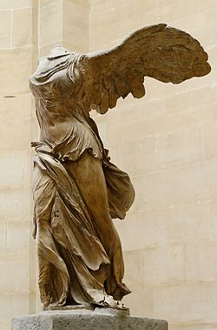

Document B: The Parthenon
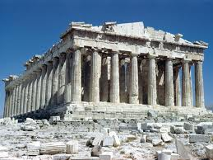
Background Built between 447 and 432 BC, the Parthenon was a Greek temple dedicated to Athena. It serves as an excellent example of the Greek expression of harmony, symmetry, and balance. Just as Greek philosophers tried to understand the basic laws of nature, so Greek architects looked to nature for guidance.

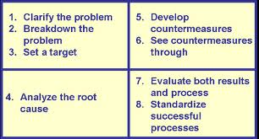
Document C: The Socratic Method

Document D: Aristotle’s Method vs. The Scientific Method

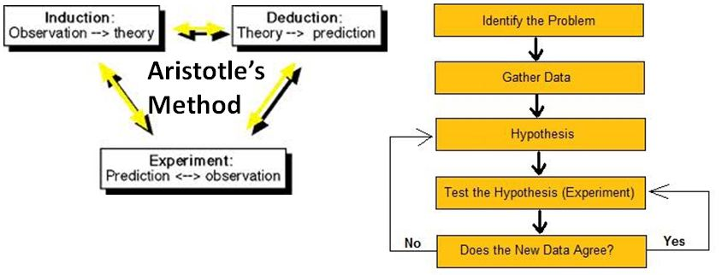

Document E: The Empire of Alexander the Great

